project final report

1. INTRODUCTION
1.1 Project Overview
The Sports Hall Booking System using ServiceNow Service Portal is a web-based application developed to simplify the process of reserving sports facilities within an educational institution. Traditionally, sports hall reservations are managed manually through registers or by contacting the sports coordinator, which often results in scheduling conflicts, lack of transparency, inefficient resource utilization, and increased administrative workload. To overcome these limitations, this project provides a centralized online platform where users can reserve sports halls quickly and conveniently.
The application has been developed using the ServiceNow Service Portal, which offers an intuitive and responsive user interface for accessing booking services. Through the Sports Zone portal, users can select their preferred sport, choose a booking date, view available one-hour time slots, check the applicable booking charges, and confirm their reservation. The system automatically validates booking requests, prevents duplicate reservations, and stores booking details securely in the ServiceNow database.
The backend of the application is implemented using ServiceNow Server Scripts and the GlideRecord API, which handle business logic, slot validation, booking creation, and database operations. The front-end consists of HTML, CSS, and AngularJS-based widgets that provide a dynamic and interactive booking experience. The communication between the client-side widgets and the server-side scripts ensures that users always receive updated information about slot availability.
One of the major features of the system is its ability to display only the available one-hour booking slots for the selected sports hall and booking date. Already reserved slots are automatically removed from the available list, thereby eliminating booking conflicts. For bookings made on the current day, only future time slots are displayed, ensuring that users cannot reserve time periods that have already passed.
The application also calculates the booking charge automatically based on the selected sport. Different sports halls have different booking charges, which are displayed instantly when the user selects a sport. After a successful booking, the system displays a confirmation message and redirects the user to the Sports Zone home page. Users can also cancel the booking process at any time and return to the home page without affecting existing reservations.
The Sports Hall Booking System improves the overall booking process by replacing manual operations with an automated, reliable, and user-friendly digital solution. It minimizes human errors, reduces administrative effort, increases transparency, and enhances the user experience while ensuring efficient utilization of sports facilities.
1.2 Purpose
The primary purpose of the Sports Hall Booking System is to automate the reservation process for sports facilities by providing a secure and user-friendly online booking platform through the ServiceNow Service Portal. The system eliminates the need for manual booking registers and enables users to reserve sports halls from any location using a web browser.
The objectives of this project are:
- To provide an online platform for booking sports halls quickly and efficiently.
- To display real-time availability of one-hour booking slots.
- To prevent duplicate bookings through automated server-side validation.
- To calculate and display booking charges automatically based on the selected sport.
- To maintain booking information securely using the ServiceNow database.
- To improve transparency and reduce scheduling conflicts in sports facility management.
- To simplify the work of sports administrators by automating booking management.
- To provide a scalable solution that can be enhanced with additional features such as online payments, QR code verification, email notifications, and mobile application support.
The system demonstrates how the ServiceNow platform can be used to develop real-world enterprise applications beyond traditional IT service management. By integrating Service Portal widgets, client-side scripting, server-side scripting, and database operations, the project provides a practical example of modern web application development using the ServiceNow ecosystem.
2. IDEATION PHASE
2.1 Problem Statement
Sports facilities such as basketball courts, badminton courts, cricket nets, volleyball courts, and table tennis halls are important resources within educational institutions. In many colleges, the reservation of these facilities is still managed manually through registers or by directly contacting the sports coordinator. This traditional approach creates several operational challenges, including scheduling conflicts, double bookings, lack of transparency, and inefficient utilization of available sports halls.
Students often face difficulties in knowing whether a particular sports hall is available before visiting the sports office. Manual booking records are time-consuming to maintain and are prone to human errors, making it difficult for administrators to track reservations accurately. Furthermore, there is no centralized platform where users can view available time slots or reserve sports halls in advance.
Problem | Priority
Manual booking through registers. | HIGH
Duplicate bookings. | HIGH
No real-time slot availability. | HIGH
Time-consuming reservation process | HIGH
Difficulty maintaining booking records. | HIGH
Lack of centralized booking management | HIGH

To address these issues, the Sports Hall Booking System using ServiceNow Service Portal was proposed as a digital solution. The system provides an online platform where users can select a sport, choose a booking date, view available one-hour booking slots, and reserve sports halls efficiently. It automatically validates bookings, prevents duplicate reservations, calculates booking charges, and stores booking information securely in the ServiceNow database.
The project aims to improve the overall booking experience by increasing transparency, reducing administrative workload, and ensuring fair utilization of sports facilities through automation.
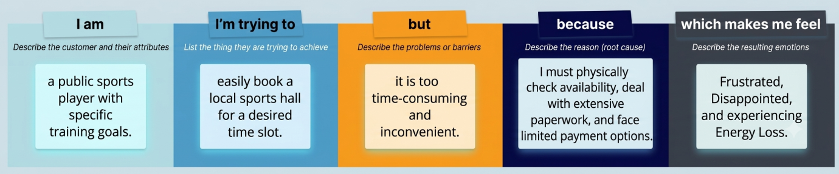

2.2 Empathy Map Canvas
During the ideation phase, an empathy map was prepared to understand the expectations, concerns, and behavior of users interacting with the sports hall booking system. Understanding user needs helped in designing a simple, reliable, and efficient booking process.
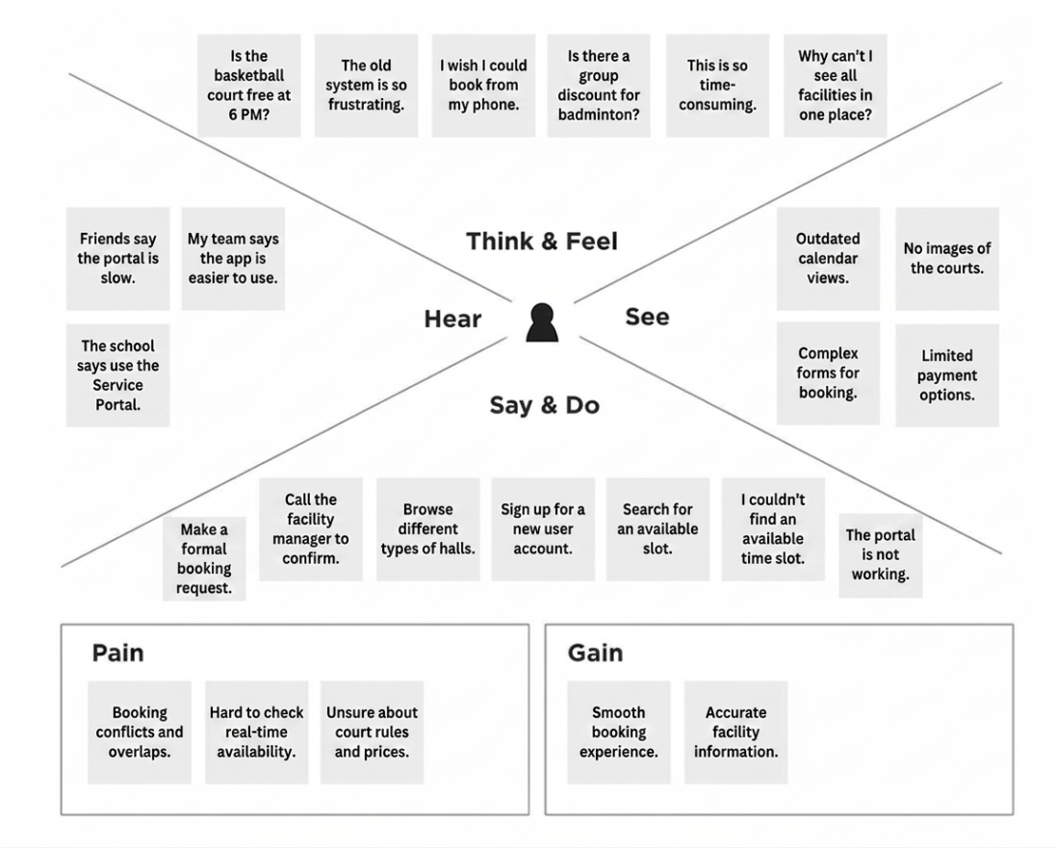
Users Think
- I want to know whether a sports hall is available before visiting the sports office.
- I need a simple and quick booking process.
- I want to avoid booking conflicts.
- I prefer booking my sports hall online instead of filling manual registers.
Users Feel
- Frustrated when halls are already occupied after reaching the venue.
- Confused about available booking timings.
- Happy when reservations can be completed quickly.
- Confident when booking confirmation is received immediately.
Users See
- Long queues during sports events.
- Manual registers maintained by sports staff.
- Difficulty in checking hall availability.
- Limited information regarding booking schedules.
Users Say
- "I wish I could check availability online."
- "Booking should take only a few minutes."
- "The system should prevent duplicate bookings."
- "It should clearly display available time slots."
Pain Points
- Manual booking process.
- Duplicate bookings.
- Lack of real-time slot availability.
- Time wasted visiting the sports office.
- Difficulty managing reservation records.
User Needs
- Online booking facility.
- Real-time slot availability.
- Easy cancellation process.
- Transparent booking charges.
- Instant booking confirmation.
The empathy map helped identify the major user expectations and guided the development of features such as real-time slot display, duplicate booking prevention, automatic booking charge calculation, and an easy-to-use Service Portal interface.

2.3 Brainstorming
The brainstorming phase focused on identifying different approaches for improving the sports hall reservation process. Multiple ideas were discussed and evaluated based on usability, implementation complexity, scalability, and overall effectiveness. Instead of selecting the first available solution, different alternatives were compared to determine the most suitable approach.
Several possible solutions were identified during brainstorming. These included maintaining manual booking registers, using spreadsheet-based booking records, developing a standalone desktop application, creating a mobile application, and building a web-based booking portal using the ServiceNow platform. Each solution was analyzed based on ease of access, maintenance effort, user experience, and future scalability.
After evaluating all alternatives, the ServiceNow Service Portal was selected as the most appropriate platform because it provides built-in database management, secure authentication, responsive user interfaces, server-side scripting capabilities, and enterprise-level scalability. It also allows seamless integration of client-side widgets with backend business logic, making it suitable for developing a centralized sports hall booking application.
Idea Prioritization Table
Idea | Description | Usability
Manual Register System | Booking through paper registers maintained by sports staff. | Low
Excel-Based Booking Management | Maintaining booking records using spreadsheets. | Medium
Desktop Application | Standalone software installed on individual computers. | Medium
Mobile Application | Dedicated Android application for sports hall booking. | High
ServiceNow Service Portal (Selected) | Centralized web portal with online booking, slot validation, and booking management. | Very High

3. REQUIREMENT ANALYSIS
Requirement Analysis is a crucial phase in the software development life cycle. It involves identifying, analyzing, and documenting the functional and non-functional requirements of the proposed system. The primary objective of this phase is to understand user expectations and convert them into clearly defined system requirements that guide the design and development process.
For the Sports Hall Booking System, the requirement analysis focused on providing an efficient, user-friendly, and reliable online booking platform. Information was gathered by studying the limitations of the existing manual booking process and understanding the expectations of students and sports administrators. The analysis helped identify the core functionalities required in the system and ensured that the developed solution satisfies user needs while maintaining scalability and security.
The following subsections describe the customer journey, solution requirements, data flow, and technology stack used in the proposed system.

3.1 Customer Journey Map
The customer journey map illustrates the complete interaction between the user and the Sports Hall Booking System. It describes each stage from accessing the Service Portal to successfully reserving a sports hall. Mapping the customer journey helped identify opportunities to simplify the booking process and improve user satisfaction.
Stage 1 – Access the Portal
The user opens the Sports Zone Service Portal through a web browser. The homepage provides navigation to different services, including the sports hall booking feature.
Stage 2 – Select Sport
The user chooses the desired sport from the available list, such as Basketball, Badminton, Cricket, Volleyball, or Table Tennis. Based on the selected sport, the system automatically displays the corresponding booking charge.
Stage 3 – Choose Booking Date
The user selects the preferred booking date using the calendar provided in the booking form. The system validates the selected date before processing further.
Stage 4 – View Available Time Slots
After selecting the sport and booking date, the system retrieves all available one-hour booking slots from the ServiceNow database. Already reserved slots are removed from the available list. If the selected date is the current day, only future time slots are displayed.
Stage 5 – Confirm Booking
The user selects an available time slot and clicks the Confirm Booking button. The system validates the request to ensure that another user has not booked the same slot during processing.
Stage 6 – Booking Confirmation
If the booking is successful, the reservation is stored in the Sports Hall Booking table, and the user receives a success message before being redirected to the Sports Zone home page.
Stage 7 – Booking Management
Users can view their existing reservations through the My Bookings page. Administrators can monitor and manage booking records using the ServiceNow platform.
Customer Journey Flow
Open Sports Zone Portal
│
▼
Select Sport
│
▼
Choose Booking Date
│
▼
View Available Slots
│
▼
Select Time Slot
│
▼
Confirm Booking
│
▼
Booking Validation
│
┌────┴────┐
│ │
Successful Already Booked
│ │
▼ ▼
Booking Saved Error Message
│
▼
Redirect to Home Page
3.2 Solution Requirement
The Sports Hall Booking System was designed to satisfy both functional and non-functional requirements identified during the analysis phase.
Functional Requirements
The system shall provide the following functionalities:
- Allow users to select a sport from the available list.
- Allow users to choose a preferred booking date.
- Display only available one-hour booking slots.
- Prevent duplicate bookings through server-side validation.
- Calculate booking charges automatically based on the selected sport.
- Store booking information securely in the ServiceNow database.
- Display booking confirmation after successful reservation.
- Allow users to cancel the booking process.
- Redirect users to the Sports Zone home page after booking or cancellation.
- Allow administrators to manage booking records.
Non-Functional Requirements
The system shall satisfy the following quality requirements:
- Easy-to-use user interface.
- Fast response time for booking operations.
- Reliable booking validation.
- Secure storage of booking information.
- High availability within the ServiceNow platform.
- Responsive design compatible with desktop and laptop browsers.
- Scalable architecture for future enhancements.
- Maintainable and modular application design.
The defined requirements ensured that the developed application fulfills user expectations while maintaining performance, reliability, and ease of maintenance.

3.3 Data Flow Diagram
The Data Flow Diagram (DFD) illustrates how information flows through the Sports Hall Booking System. It identifies the interactions between users, the Service Portal interface, server-side scripts, and the ServiceNow database.
The booking process begins when a user accesses the Service Portal and enters booking information such as the selected sport and booking date. The request is processed by the server script, which validates slot availability using the GlideRecord API. If the selected slot is available, booking details are stored in the Sports Hall Booking table. If the slot has already been reserved, an appropriate error message is returned to the user. After successful booking, confirmation is displayed, and the user is redirected to the home page.
The DFD ensures that data movement remains organized, secure, and efficient throughout the booking process.
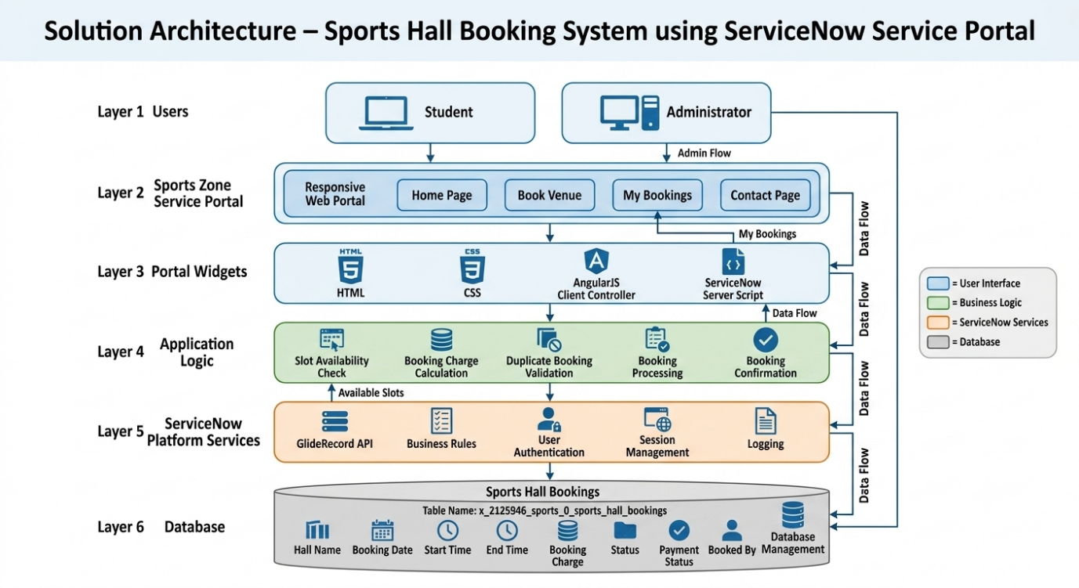

Figure 3.1: Data Flow Diagram of Sports Hall Booking System

3.4 Technology Stack
The Sports Hall Booking System was developed using the ServiceNow platform and several web technologies. Each technology contributes to a specific component of the application.
Technology | Purpose
ServiceNow | Enterprise application development platform
Service Portal | Web-based user interface
HTML | Structure of booking pages
CSS | Styling and responsive design
AngularJS | Client-side interactions and dynamic content
JavaScript | Booking logic and event handling
Server Scripts | Backend business logic
GlideRecord API | Database operations
ServiceNow Tables | Store booking information
Personal Developer Instance (PDI) | Development and testing environment
The selected technology stack provides a scalable, secure, and maintainable architecture while leveraging the capabilities of the ServiceNow ecosystem. The modular design also allows additional features, such as online payment integration and mobile access, to be incorporated in future versions.
4. PROJECT DESIGN
The project design phase transforms the identified requirements into a practical software solution. Based on the problem analysis and user requirements gathered during the previous phases, a systematic design was developed to ensure that the Sports Hall Booking System is reliable, user-friendly, secure, and scalable. The project design defines the overall structure of the application, describes the interaction between different components, and explains how the proposed solution addresses the existing challenges in sports hall reservation.
The Sports Hall Booking System has been designed using the ServiceNow Service Portal architecture, where users interact with a responsive web interface while the business logic is handled by ServiceNow Server Scripts. The system follows a modular design approach, making future enhancements easier to implement.

4.1 Problem Solution Fit
The proposed solution directly addresses the challenges identified during the problem analysis phase. The existing manual booking process suffers from scheduling conflicts, duplicate bookings, lack of transparency, and inefficient management of sports facilities. The developed Sports Hall Booking System eliminates these limitations by automating the complete reservation process.
The relationship between the identified problems and the implemented solution is presented below.
Problem Identified | Proposed Solution
Manual booking registers | Online booking through ServiceNow Service Portal
Double booking of sports halls | Automatic duplicate booking validation
No real-time availability information | Dynamic display of available one-hour slots
Time-consuming booking process | Simple online booking interface
Difficulty managing booking records | Centralized ServiceNow database
Manual calculation of booking charges | Automatic charge calculation based on selected sport
Poor user experience | Responsive and user-friendly Service Portal
The developed solution ensures that every booking request is validated before confirmation. Users are able to check available slots in real time, reducing unnecessary visits to the sports office and improving transparency in sports facility management.

4.2 Proposed Solution
The proposed Sports Hall Booking System is designed as a centralized web application that enables students and staff to reserve sports facilities through the ServiceNow Service Portal. The application provides a simple and intuitive interface where users can complete the booking process within a few clicks.
The overall workflow of the system is described below:
Step 1 – User Access
The user opens the Sports Zone Service Portal using a web browser.
Step 2 – Sport Selection
The user selects the desired sport from the available dropdown list.
Example:
- Basketball
- Badminton
- Cricket
- Volleyball
- Table Tennis
Immediately after selecting the sport, the corresponding booking charge is displayed.

Step 3 – Booking Date Selection
The user chooses the preferred booking date using the calendar control.
The system validates the selected date before processing further.

Step 4 – Display Available Slots
Once both sport and booking date are selected, the system communicates with the server.
The server script performs the following operations:
- Reads booking records from the ServiceNow database.
- Identifies already reserved slots.
- Removes booked slots from the available list.
- Displays only available one-hour slots.
- If today's date is selected, past time slots are automatically hidden.

Step 5 – Booking Confirmation
The user selects an available slot and clicks Confirm Booking.
The server performs another validation to ensure that no duplicate booking has occurred while the user was selecting the slot.
If validation succeeds:
- Booking record is inserted into the database.
- Success message is displayed.
- User is redirected to the Sports Zone home page.
If validation fails:
- Appropriate error message is displayed.
- Updated available slots are shown.

Step 6 – Booking Management
Administrators can monitor all bookings through admin dashboard page, while users can access their booking information through the My Bookings page.

Features of the Proposed Solution
- Online sports hall reservation
- Real-time slot availability
- One-hour booking slots
- Automatic booking charge calculation
- Duplicate booking prevention
- Secure database storage
- Responsive user interface
- Easy navigation
- Future scalability
The proposed solution significantly reduces manual effort while improving booking accuracy and user satisfaction.

4.3 Solution Architecture
The Sports Hall Booking System follows a three-layer architecture consisting of the Presentation Layer, Business Logic Layer, and Data Layer. Each layer performs specific responsibilities, ensuring modularity, maintainability, and efficient communication between the user interface and the database.
Presentation Layer
The Presentation Layer represents the Sports Zone Service Portal, which serves as the primary interface between users and the application. It is developed using HTML, CSS, AngularJS, and Service Portal widgets.
Responsibilities include:
- Display booking form
- Sport selection
- Booking date selection
- Display available slots
- Display booking charge
- Booking confirmation
- User navigation

Business Logic Layer
The Business Logic Layer is implemented using ServiceNow Server Scripts.
This layer performs all application processing, including:
- Receiving booking requests
- Validating user inputs
- Checking slot availability
- Preventing duplicate bookings
- Calculating booking charges
- Creating booking records
- Returning booking status
The GlideRecord API is used for database communication.

Data Layer
The Data Layer consists of the ServiceNow database.
Booking information is stored inside the following custom table:
Sports Hall Bookings
The table stores:
- Hall Name
- Booking Date
- Start Time
- End Time
- Booking Charge
- Booking Status
- Payment Status
- Booked By
- System Generated Information
Solution Architecture Workflow
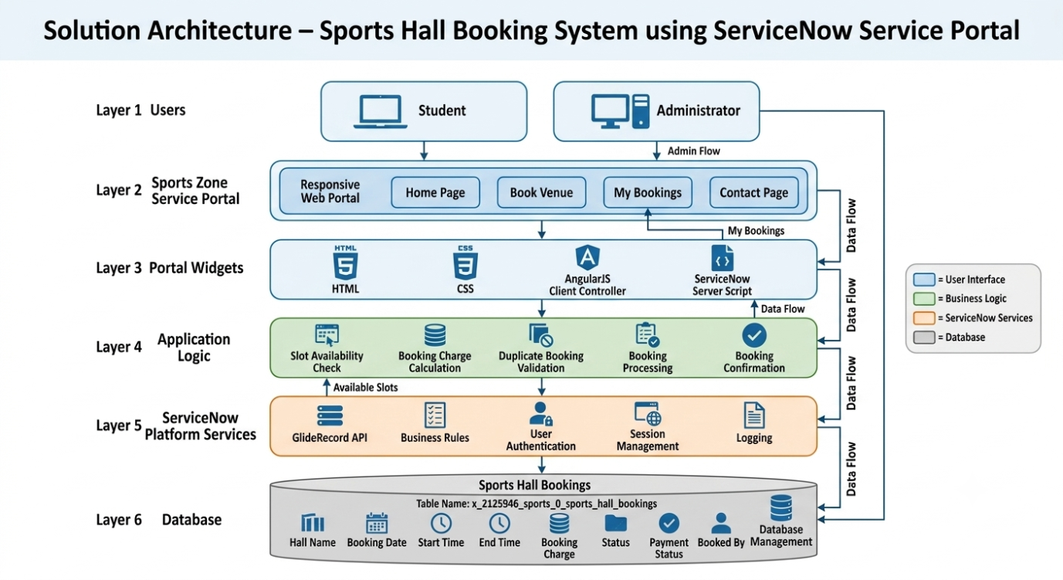Figure 4.1: Solution Architecture of Sports Hall Booking System
The architecture ensures secure communication between the client interface and the ServiceNow database while maintaining a modular design. The separation of presentation, business logic, and data storage improves maintainability and allows future enhancements such as online payment integration, QR-based entry verification, email notifications, and mobile application support without major architectural changes.
5. PROJECT PLANNING & SCHEDULING
Project planning is one of the most important phases of software development as it provides a clear roadmap for executing the project successfully. It defines the sequence of activities, project milestones, timelines, and resource allocation required to complete the system within the planned schedule. Proper planning helps in monitoring project progress, minimizing delays, and ensuring that all functional requirements are implemented efficiently.
The Sports Hall Booking System was planned using the Agile Scrum methodology, where the project was divided into two sprints. Each sprint consisted of multiple user stories grouped under related epics. Story points were assigned based on the complexity and estimated effort required to complete each user story. The Agile approach enabled continuous development, testing, and validation of system functionalities while maintaining flexibility throughout the development process.
The project planning phase included requirement identification, user story preparation, sprint planning, story point estimation, sprint scheduling, and project progress monitoring.

5.1 Project Planning
The Sports Hall Booking System was divided into two development sprints. The first sprint focused on designing the user interface and implementing the core booking functionalities. The second sprint concentrated on booking validation, database integration, testing, and optimization of the application.
Each user story was assigned a story point value based on the estimated development effort. Lower story points represented simple tasks, while higher story points represented more complex implementation activities.
Sprint 1
Sprint 1 mainly focused on developing the front-end interface and implementing the core booking functionality.
Epic 1 – User Interface Development
- USN-1 : Design Sports Zone Service Portal
- USN-2 : Develop Book Venue Interface
Epic 2 – Booking Functionality
- USN-3 : Sport Selection
- USN-4 : Booking Date Selection
- USN-5 : Display Available Time Slots
The total effort estimated for Sprint 1 was 12 Story Points.

Sprint 2
Sprint 2 focused on implementing the backend logic and improving system reliability.
Epic 3 – Booking Validation
- USN-6 : Duplicate Booking Prevention
- USN-7 : Booking Charge Calculation
- USN-8 : Database Integration
Epic 4 – Testing and Deployment
- USN-9 : Functional Testing
- USN-10 : Performance Testing
- USN-11 : User Acceptance Testing
The total effort estimated for Sprint 2 was 20 Story Points.

Story Point Estimation
Story points were estimated using the Fibonacci sequence, where each value represented the relative effort required for implementing a user story.
Story Point | Complexity Level
1 | Very Easy
2 | Easy
3 | Moderate
5 | Complex
Story points helped estimate development effort rather than actual development time.

Sprint Summary
Sprint | Story Points | Duration
Sprint 1 | 11 | 3 Days
Sprint 2 | 11 | 3 Days
Total Story Points = 22

Team Velocity
Team velocity represents the average number of story points completed during each sprint. Since the project consisted of two sprints, the velocity was calculated using the following formula:
$$\text{Velocity}=\frac{\text{Total Story Points Completed}}{\text{Number of Sprints}}$$
Substituting the project values:
- Total Story Points = 22
- Number of Sprints = 2
Therefore,
$$\text{Velocity}=\frac{22}{2}=11$$
Team Velocity = 11 Story Points per Sprint
Although this project was developed individually, Agile planning techniques such as sprint scheduling, story point estimation, and velocity calculation were followed to maintain an organized development process.

Sprint Timeline
The planned schedule for the project is presented below.
Sprint | Start Date | End Date | Duration
Sprint 1 | 1 July 2026 | 3 July 2026 | 3 Days
Sprint 2 | 3 July 2026 | 6 July 2026 | 3 Days
The project activities were completed according to the planned schedule, with each sprint concluding after successful implementation and testing of the assigned user stories.

Project Progress Monitoring
Project progress was monitored using Agile sprint planning techniques. At the end of each sprint, completed user stories were reviewed and validated through functional testing. Any identified issues were corrected before proceeding to the next sprint. Continuous testing ensured that the application remained stable throughout development.
The burndown chart prepared during project planning demonstrated a steady reduction in the remaining story points, indicating that the project progressed according to schedule and all planned tasks were completed successfully.
6. FUNCTIONAL AND PERFORMANCE TESTING
Testing is an essential phase of software development that ensures the developed application performs according to the specified requirements. The Sports Hall Booking System was tested to verify the correctness of its functionality, reliability, and performance. Different types of testing, including functional testing, performance testing, and user acceptance testing, were conducted to identify and resolve issues before deployment.
The primary objective of testing was to ensure that users could successfully reserve sports halls, view available time slots, prevent duplicate bookings, and navigate the application without errors.

6.1 Performance Testing
Performance testing was conducted to evaluate the responsiveness and reliability of the Sports Hall Booking System under normal operating conditions. The system was tested by performing multiple booking operations and verifying the response time for each request.
The booking confirmation process was completed within an acceptable time, and available slots were retrieved efficiently from the ServiceNow database. The application successfully prevented duplicate bookings while maintaining consistent performance throughout testing.
The following performance observations were recorded:
Parameter | Result
Booking Response Time | Less than 3 Seconds
Available Slot Loading Time | Less than 2 Seconds
Duplicate Booking Validation | Successful
Functional Test Cases Passed | 100%
Overall System Stability | Stable
The testing results indicate that the application performs efficiently under normal usage and provides a smooth booking experience.

Functional Testing Summary
Functional testing was carried out to verify that every feature of the application worked according to the specified requirements. The following functionalities were successfully validated:
- Sports selection
- Booking date selection
- Display of available slots
- Booking charge calculation
- Booking confirmation
- Duplicate booking prevention
- Cancel booking functionality
- Navigation between pages
All planned functional test cases were executed successfully without critical failures.

User Acceptance Testing
User Acceptance Testing (UAT) was performed to ensure that the developed application satisfies user expectations and business requirements. During UAT, users verified the complete booking process from selecting a sport to confirming a reservation.
The system successfully displayed available slots, prevented duplicate bookings, calculated booking charges correctly, and redirected users after successful booking. Feedback received during testing confirmed that the application was easy to use and met the intended objectives.

Bug Resolution
During development, a few issues were identified and resolved before the final deployment.
Issue | Resolution
Booked slots appeared in available slots | Modified the server-side slot validation logic.
Booking charge not updating | Updated the Client Controller to refresh charges dynamically.
Duplicate booking validation delay | Improved server-side validation before booking confirmation.
After resolving these issues, the application functioned correctly and all major features were successfully verified.
7. RESULTS
The Sports Hall Booking System was successfully developed and deployed using the ServiceNow Service Portal. The application automates the complete sports hall reservation process by allowing users to select a sport, choose a booking date, view available one-hour time slots, and confirm bookings through an intuitive web interface.
The system was tested under different booking scenarios to verify its functionality. It correctly displayed only available slots, prevented duplicate bookings, calculated booking charges automatically, and stored booking details securely in the ServiceNow database. The application performed reliably and satisfied all the functional requirements identified during the requirement analysis phase.
The following screenshots illustrate the successful implementation of the system.

7.1 Output Screenshots
Figure 7.1: Sports Zone Home Page
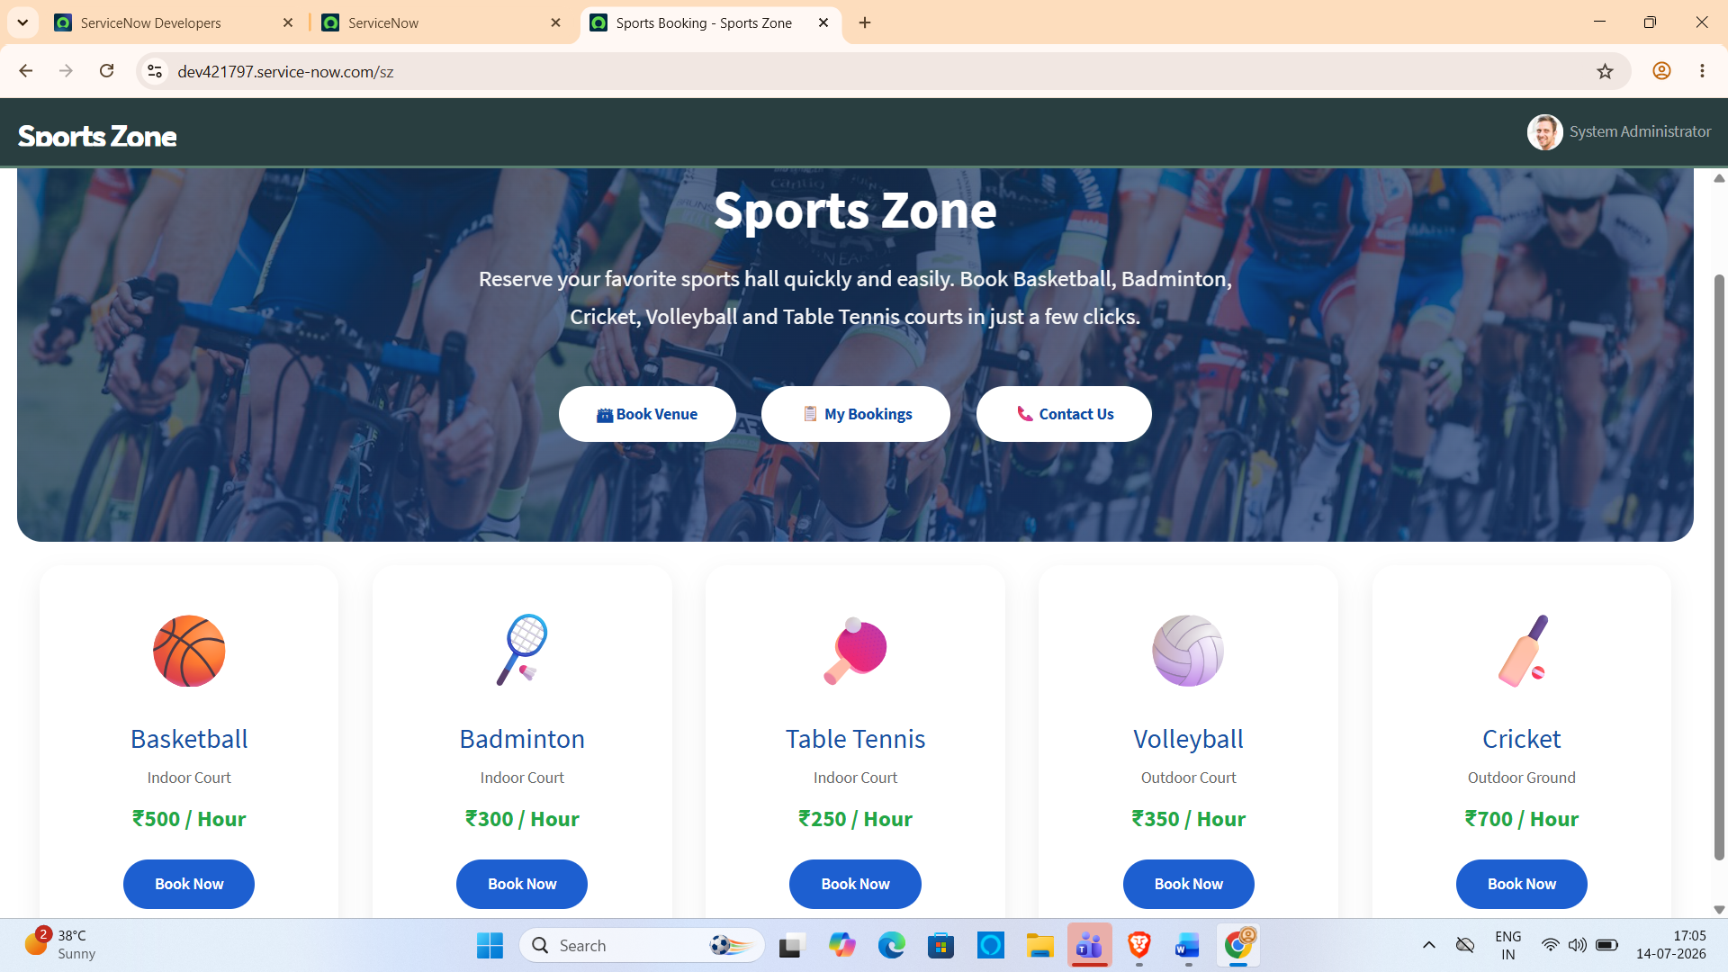
The Sports Zone homepage serves as the main entry point of the application. It provides navigation to the Book Venue, My Bookings, and Contact pages through a clean and user-friendly interface.

Figure 7.2: Book Venue Page
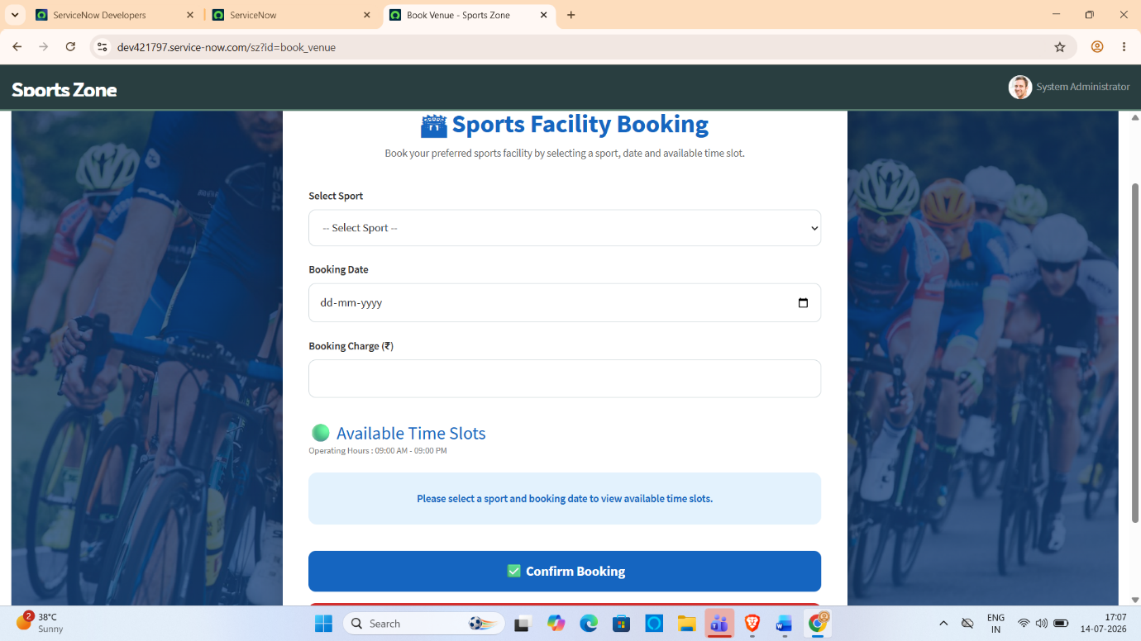
The Book Venue page allows users to select a sport, choose a booking date, view available one-hour time slots, check the booking charge, and reserve the selected sports hall.

Figure 7.3: Available Slot Display
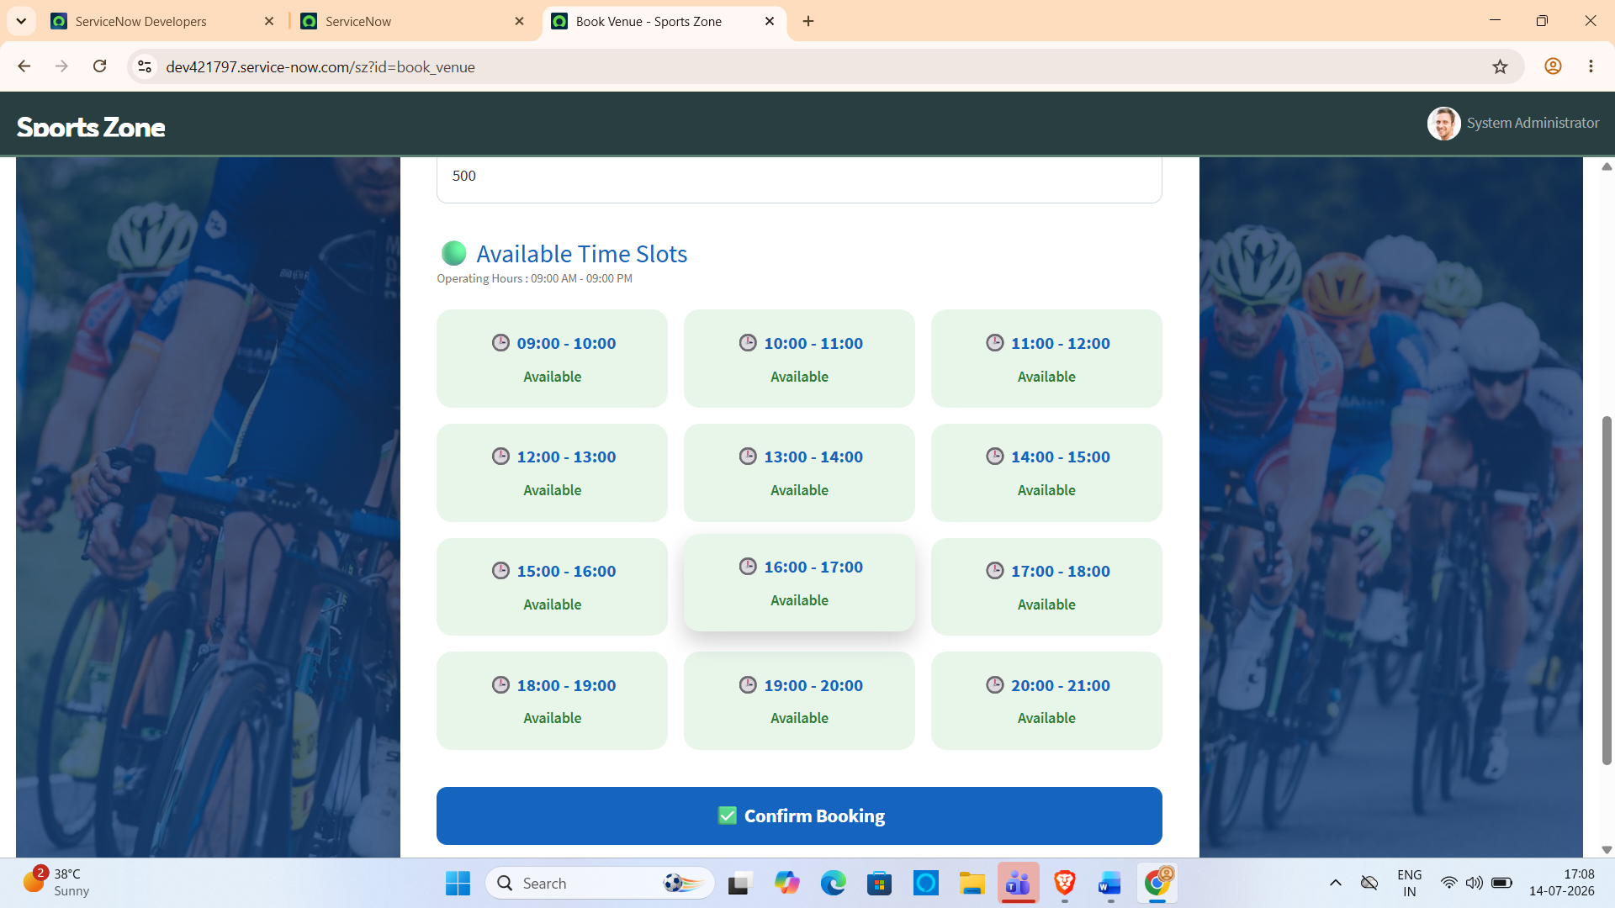After selecting the sport and booking date, the system dynamically retrieves and displays only the available booking slots. Already booked slots are automatically removed from the list, ensuring conflict-free reservations.

Figure 7.4: Booking Confirmation
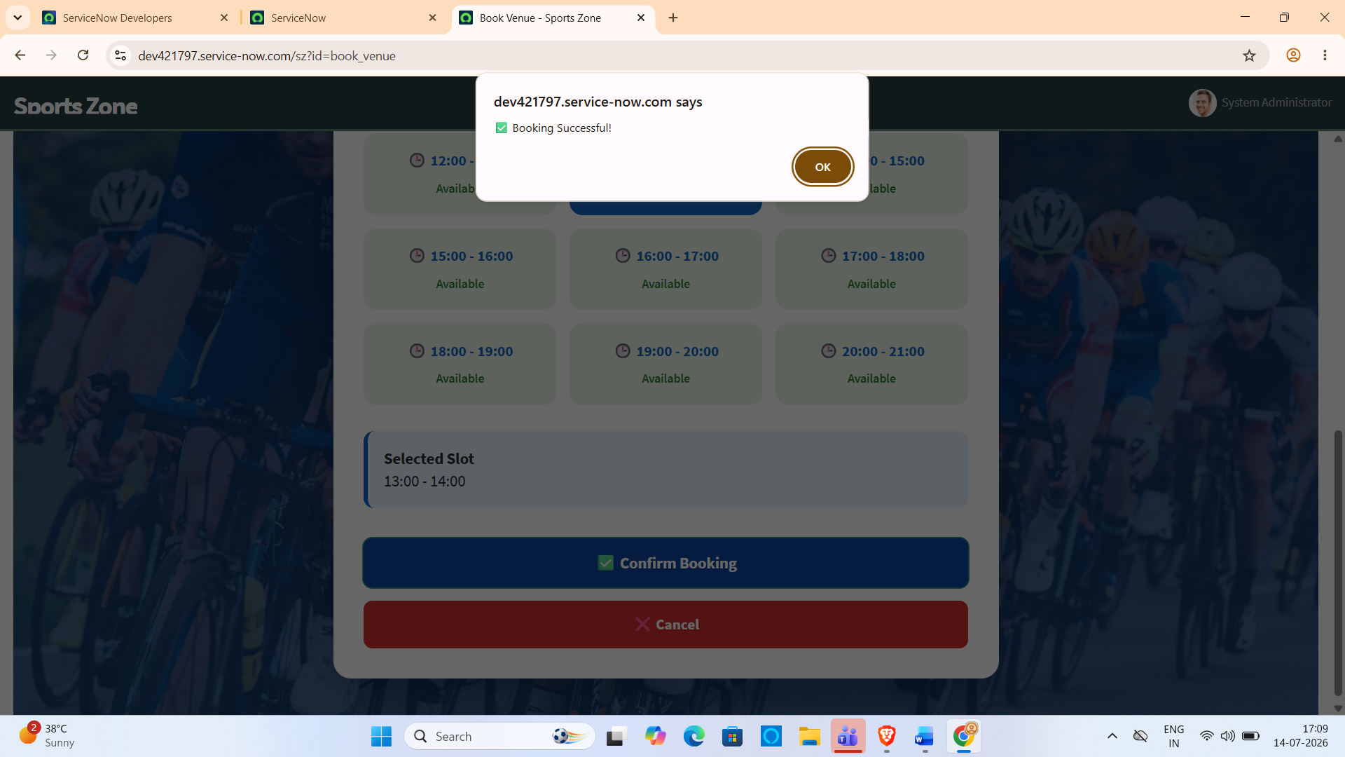
Once the booking is confirmed successfully, the system displays a confirmation message and redirects the user to the Sports Zone home page. The booking information is stored securely in the ServiceNow database.

Figure 7.5: My Bookings Page
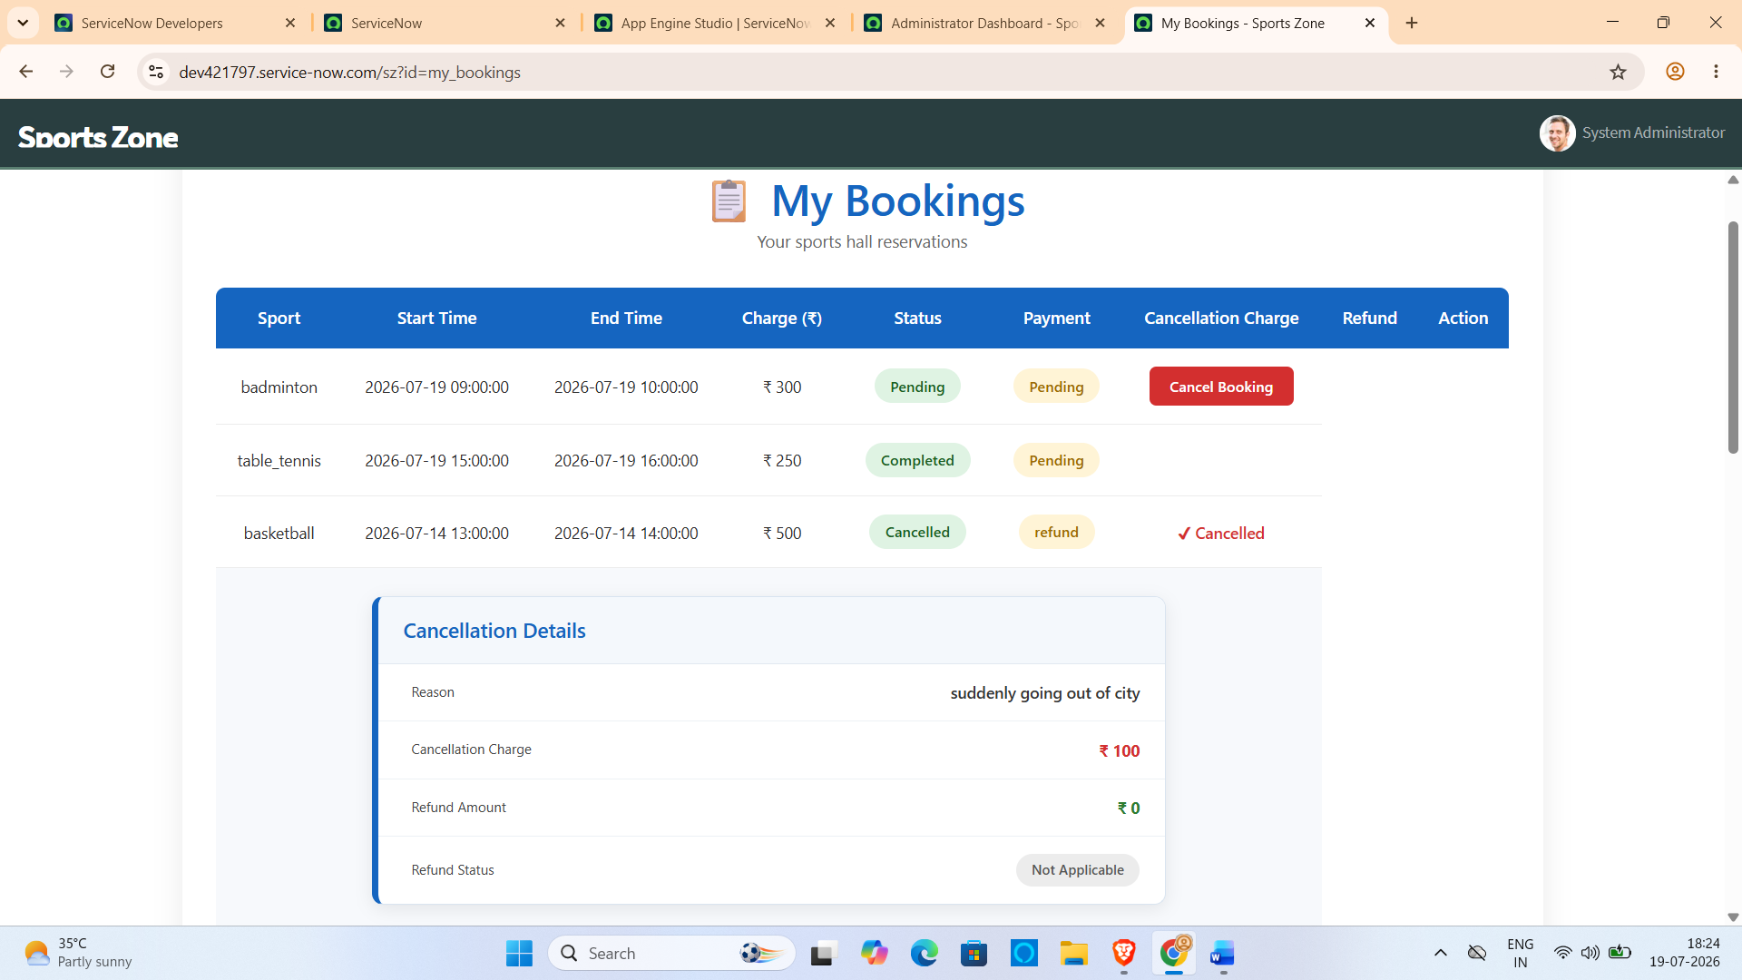
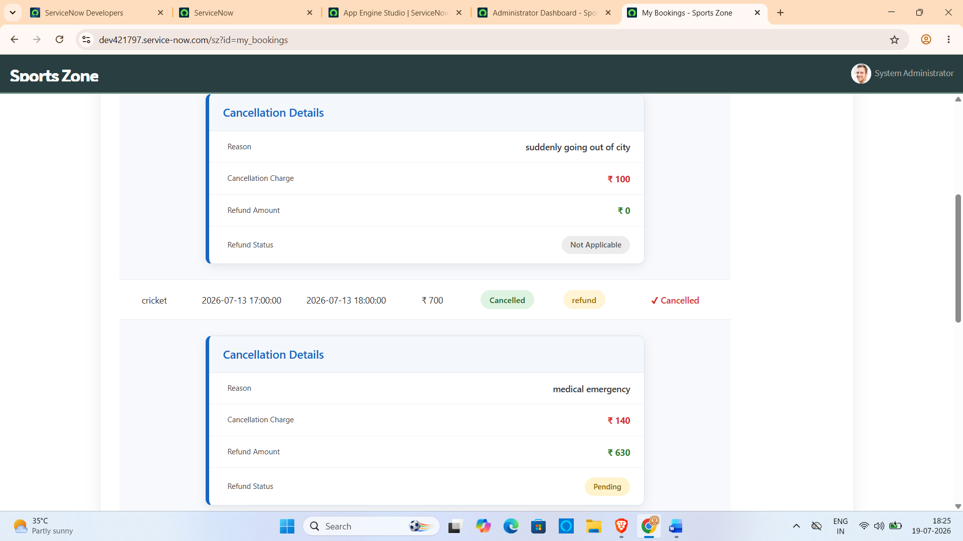
The My Bookings page enables users to view their existing reservations. It provides booking details such as sport, booking date, time slot, booking status, and booking charge.

Figure 7.6: Contact Page
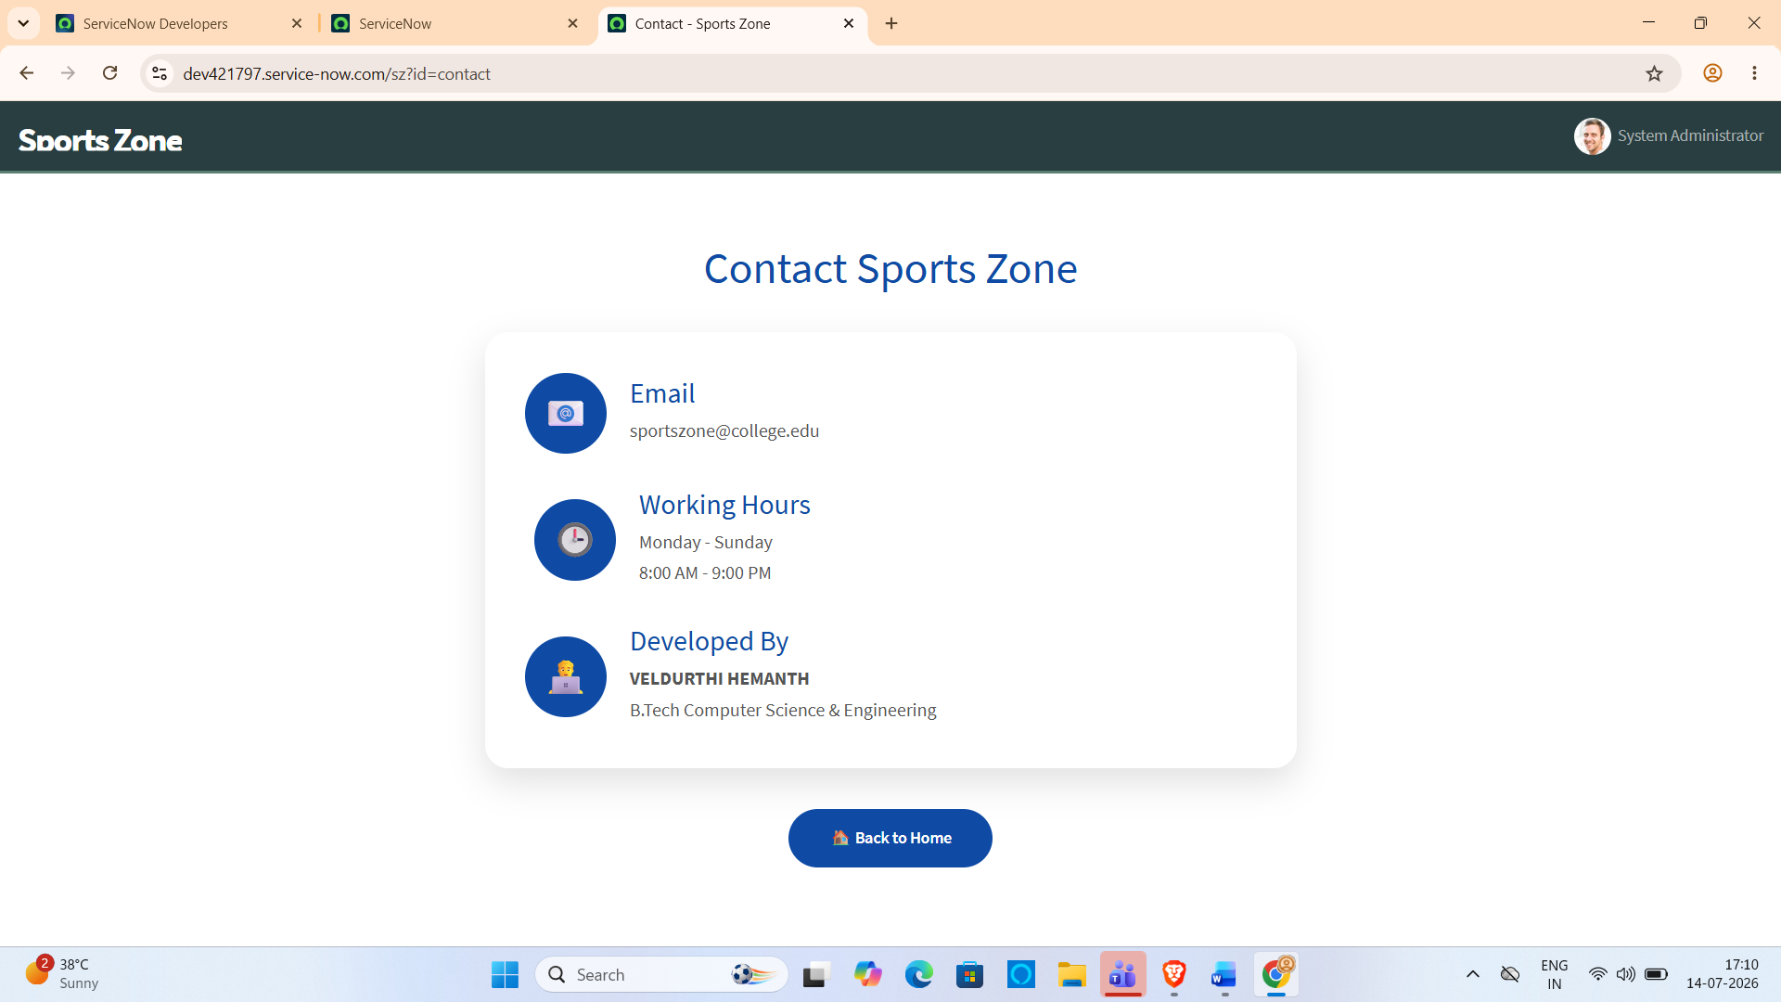The Contact page provides users with the necessary contact information for sports administrators and support in case of booking-related queries or assistance.

Administrator Dashboard Module

1. Module Overview
The Administrator Dashboard is the central control panel of the Sports Hall Booking System. It provides administrators with a single interface to monitor all booking activities, manage booking requests, process refunds, and supervise the overall operation of the sports hall reservation system.
Unlike the user portal, the administrator dashboard provides additional privileges such as approving or rejecting bookings, completing reservations, managing refund requests, monitoring payment status, viewing booking statistics, and enabling or disabling sports halls.

Objectives
The Administrator Dashboard was developed to achieve the following objectives:
- Monitor all sports hall bookings.
- Approve or reject booking requests.
- Complete or cancel approved bookings.
- Monitor payment status of each booking.
- Process refund requests for cancelled bookings.
- Display booking statistics through dashboard cards.
- Enable or disable sports halls.
- Improve administrative efficiency by managing the entire booking system from one interface.

Administrator Dashboard Features
The dashboard contains four major modules.

Dashboard
Displays overall statistics of the booking system.
Dashboard cards include:
- Total Bookings
- Pending Bookings
- Approved Bookings
- Cancelled Bookings
- Completed Bookings
- Today's Revenue
- Pending Refunds
- Most Booked Sport
The dashboard automatically calculates these values whenever the page is loaded using GlideRecord queries.
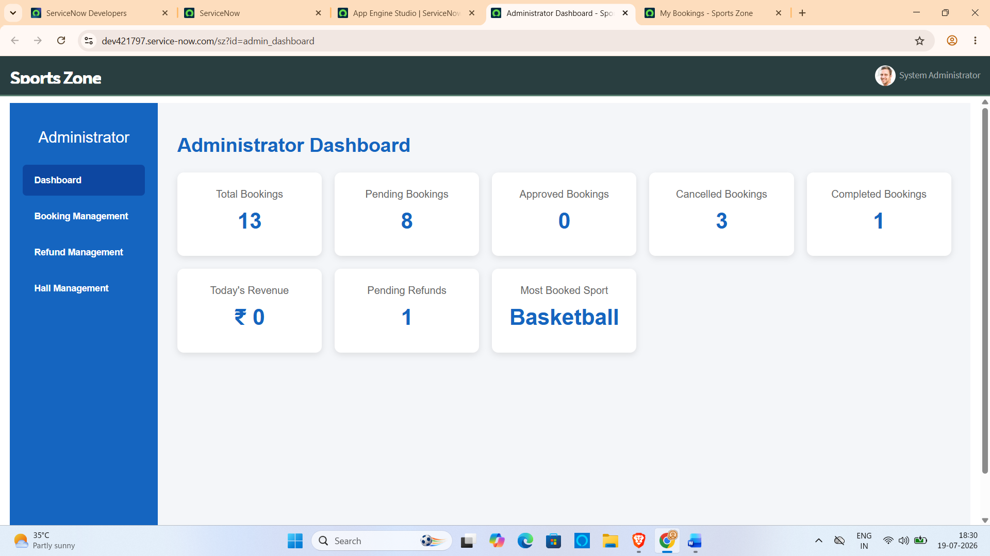

Booking Management
Allows the administrator to manage every booking made by users.
Displayed Information:
- User Name
- Sports Hall
- Booking Start Time
- Booking Charge
- Booking Status
- Payment Status
Administrative Actions:
- Approve Booking
- Reject Booking
- Complete Booking
- Cancel Booking
- Mark Payment as Paid (if payment is pending)
Whenever an action is performed, the corresponding booking record is updated instantly in the database.
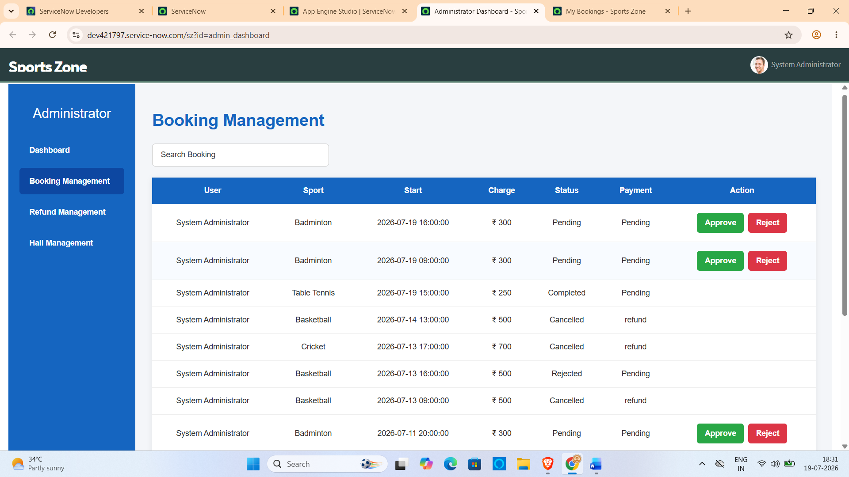

Refund Management
The refund module handles cancellation refunds.
Displayed Information:
- User Name
- Sports Hall
- Cancellation Reason
- Cancellation Charge
- Refund Amount
- Refund Status
Administrative Actions:
- Approve Refund
When the administrator approves a refund:
- Refund Status changes from Pending to Refunded.
- Refund information is permanently stored in the booking record.
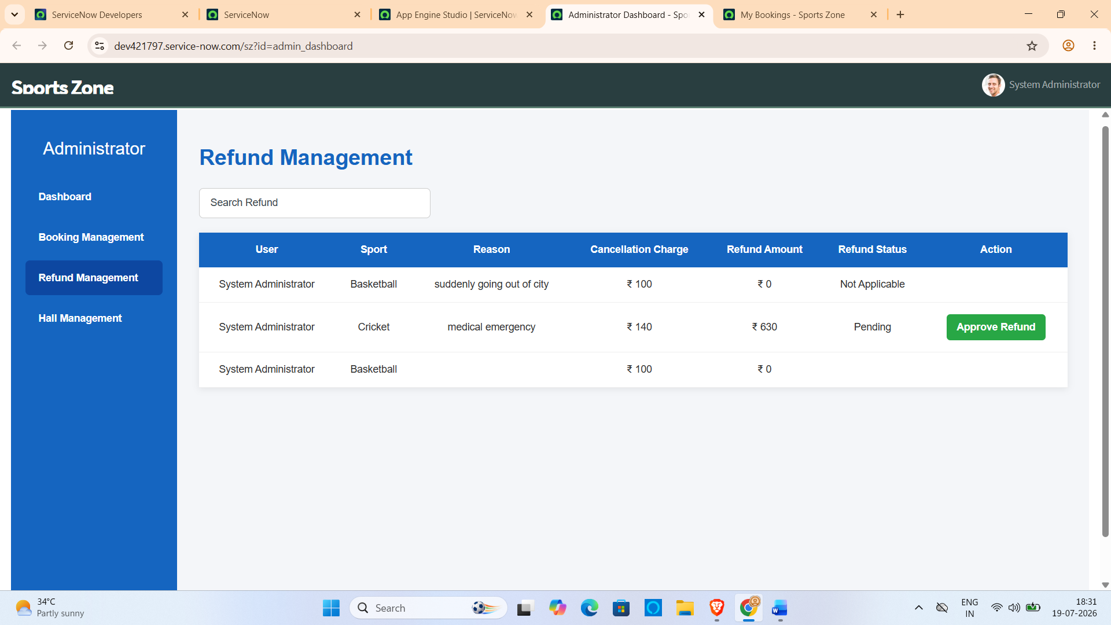

Sports Hall Management
The Sports Hall Management section enables the administrator to control the availability of sports halls.
The administrator can:
- Enable Basketball Hall
- Disable Basketball Hall
- Enable Badminton Hall
- Disable Badminton Hall
- Enable Table Tennis Hall
- Disable Table Tennis Hall
- Enable Volleyball Hall
- Disable Volleyball Hall
- Enable Cricket Hall
- Disable Cricket Hall
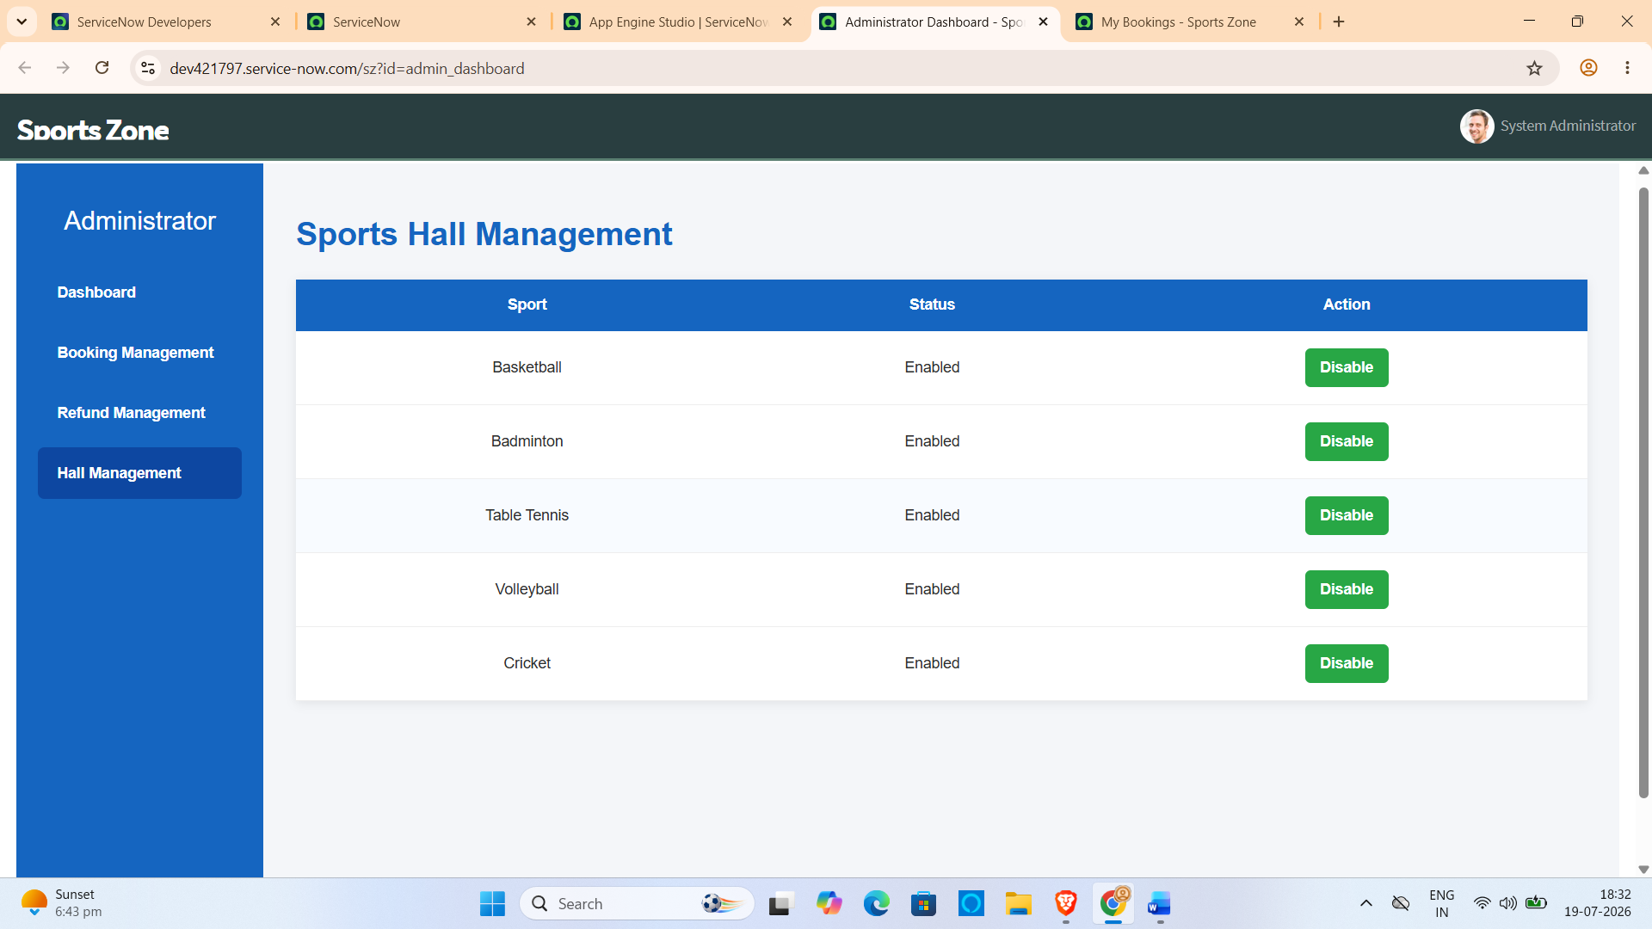

Result Summary
The developed Sports Hall Booking System successfully achieved all the planned objectives. The application provides an efficient and reliable online booking platform that simplifies sports hall reservations and reduces manual effort.
The major outcomes of the project include:
- Successful online sports hall booking through the ServiceNow Service Portal.
- Dynamic display of available one-hour booking slots.
- Automatic booking charge calculation based on the selected sport.
- Prevention of duplicate bookings through server-side validation.
- Secure storage of booking information in the ServiceNow database.
- Simple and responsive user interface for improved user experience.
Overall, the system demonstrated stable performance and met all the functional requirements defined during the planning and design phases.

8. ADVANTAGES & DISADVANTAGES
The Sports Hall Booking System provides a modern and efficient approach to managing sports facility reservations. By replacing the traditional manual booking process with an online ServiceNow-based solution, the system improves transparency, minimizes booking conflicts, and enhances the overall user experience. Although the application offers several advantages, it also has certain limitations that can be addressed in future enhancements.

8.1 Advantages
The major advantages of the proposed Sports Hall Booking System are:
- Provides an online platform for booking sports halls anytime through the ServiceNow Service Portal.
- Displays real-time availability of one-hour booking slots.
- Prevents duplicate bookings using server-side validation.
- Automatically calculates booking charges based on the selected sport.
- Reduces paperwork and manual record maintenance.
- Improves transparency in sports facility management.
- Simple and user-friendly interface that requires minimal training.
- Stores booking information securely in the ServiceNow database.
- Reduces administrative workload by automating the reservation process.
- Can be extended easily with additional features in future versions.

8.2 Disadvantages
Although the system performs efficiently, it has a few limitations:
- Requires an active internet connection to access the Service Portal.
- Depends on the availability of the ServiceNow platform.
- Currently supports only fixed one-hour booking slots.
- Online payment functionality is not included in the current version.
- Mobile application support is not available.
- QR code-based entry verification is not provided.
- Designed primarily for sports hall booking and requires customization for other facility management scenarios.

Summary
Overall, the advantages of the Sports Hall Booking System significantly outweigh its limitations. The application successfully automates the sports hall reservation process, improves user convenience, and ensures efficient utilization of sports facilities. The identified limitations provide opportunities for future improvements and system expansion.
9. CONCLUSION
The Sports Hall Booking System using ServiceNow Service Portal was successfully designed, developed, and tested to provide an efficient solution for managing sports facility reservations. The project successfully replaces the traditional manual booking process with a centralized online platform that enables users to reserve sports halls quickly and conveniently.
The developed system allows users to select a sport, choose a booking date, view available one-hour time slots, and confirm bookings through an intuitive web interface. The application automatically calculates booking charges, prevents duplicate reservations through server-side validation, and stores booking information securely in the ServiceNow database. These features improve transparency, reduce administrative workload, and enhance the overall booking experience.
Throughout the project, Agile development practices were followed by dividing the implementation into two sprints. Functional testing, performance testing, and user acceptance testing were conducted to verify the correctness and reliability of the application. The testing results confirmed that the system meets all the functional requirements and performs efficiently under normal operating conditions.
The project also demonstrates the practical application of the ServiceNow platform beyond traditional IT Service Management by utilizing Service Portal widgets, Client Controllers, Server Scripts, and GlideRecord APIs to develop a real-world enterprise application.
Overall, the Sports Hall Booking System achieved its objectives by providing a reliable, secure, and user-friendly booking solution. The application simplifies sports facility management, improves resource utilization, and establishes a strong foundation for future enhancements such as online payment integration, QR code verification, email notifications, and mobile application support.
10. FUTURE SCOPE
The current version of the Sports Hall Booking System using ServiceNow Service Portal successfully automates the sports hall reservation process and fulfills the essential requirements of online booking. However, the system can be further enhanced by incorporating additional features that improve user convenience, administrative efficiency, and overall system functionality.
One of the major enhancements that can be implemented is online payment integration, allowing users to complete booking payments through secure digital payment gateways. This would eliminate manual payment handling and provide a complete end-to-end booking solution.
The system can also be enhanced by implementing email and SMS notifications to automatically inform users about booking confirmations, reminders, cancellations, and schedule updates. Such notifications would improve communication and reduce missed bookings.
A QR Code-based entry verification system can be introduced, where users receive a unique QR code after successful booking. Sports administrators can scan the QR code to verify reservations before allowing entry into the sports facility.
To improve accessibility, a mobile application can be developed for Android and iOS devices. A mobile version would allow users to reserve sports halls, view bookings, and receive notifications directly from their smartphones.
Future versions can also include an administrator dashboard with graphical reports and analytics. The dashboard could display hall utilization statistics, booking trends, revenue reports, and user activity, helping administrators make better decisions regarding facility management.
Another possible enhancement is multi-campus support, allowing a single application to manage sports facilities across multiple colleges or campuses. This would make the system suitable for large educational institutions with several sports complexes.
Additionally, the application can incorporate AI-based slot recommendations, suggesting suitable booking times based on previous booking history and hall availability. This would further improve user experience and optimize resource utilization.
By implementing these enhancements, the Sports Hall Booking System can evolve into a comprehensive sports facility management solution capable of supporting larger organizations and providing a more intelligent and convenient booking experience.
11. APPENDIX
The appendix contains supplementary information related to the implementation of the Sports Hall Booking System. It includes details of the source code, development environment, project configuration, and references used during development. These resources provide additional technical information and support the implementation presented in this report.

11.1 Source Code
The source code of the Sports Hall Booking System was developed using the ServiceNow platform and consists of the following major components:
- Service Portal Widgets
- HTML
- CSS
- AngularJS Client Controller
- Server Script
- GlideRecord Database Operations
- Custom Sports Hall Booking Table
- Business Rules
- Service Portal Pages
- Contact Page
- My Bookings Page
The complete source code is maintained within the ServiceNow Personal Developer Instance (PDI).

11.2 Dataset Link
This project does not require any external dataset because all booking information is stored dynamically within the ServiceNow database.
11.3 GitHub Repository
The source code can be maintained using GitHub for version control and future enhancements.
GitHub Repository:
https://github.com/228x1a05g6-dev/Sports-Hall-Booking-System-by-Service-Portal

11.4 Project Demo Link
The project demonstration video explains the working of the Sports Hall Booking System, including the booking process, slot availability, duplicate booking prevention, and booking management.
Project Demo Link:
https://drive.google.com/file/d/1H3SrzRsxqNMEqnidK_ZEi1Y1MiUkgKVE/view?usp=drive_link

11.5 Development Environment
Component | Details
Platform | ServiceNow Personal Developer Instance (PDI)
Application | Sports Hall Booking System
User Interface | Service Portal
Front-end | HTML, CSS, AngularJS
Backend | ServiceNow Server Scripts
Database | ServiceNow Custom Table
API | GlideRecord
Browser | Google Chrome
Operating System | Windows 10/11

11.6 Project Configuration
The following configurations were completed during project development:
- Created custom application in ServiceNow.
- Designed Sports Zone Service Portal.
- Developed Book Venue widget.
- Configured custom Sports Hall Booking table.
- Implemented server-side booking validation.
- Configured available slot management.
- Implemented duplicate booking prevention.
- Developed My Bookings page.
- Developed Contact page.
- Performed functional and performance testing.

References
- ServiceNow Documentation – Service Portal Development
- ServiceNow Developer Documentation – GlideRecord API
- ServiceNow Learning Portal
- Agile Scrum Guide
- HTML5 Documentation
- CSS3 Documentation
- AngularJS Documentation
- JavaScript Documentation

